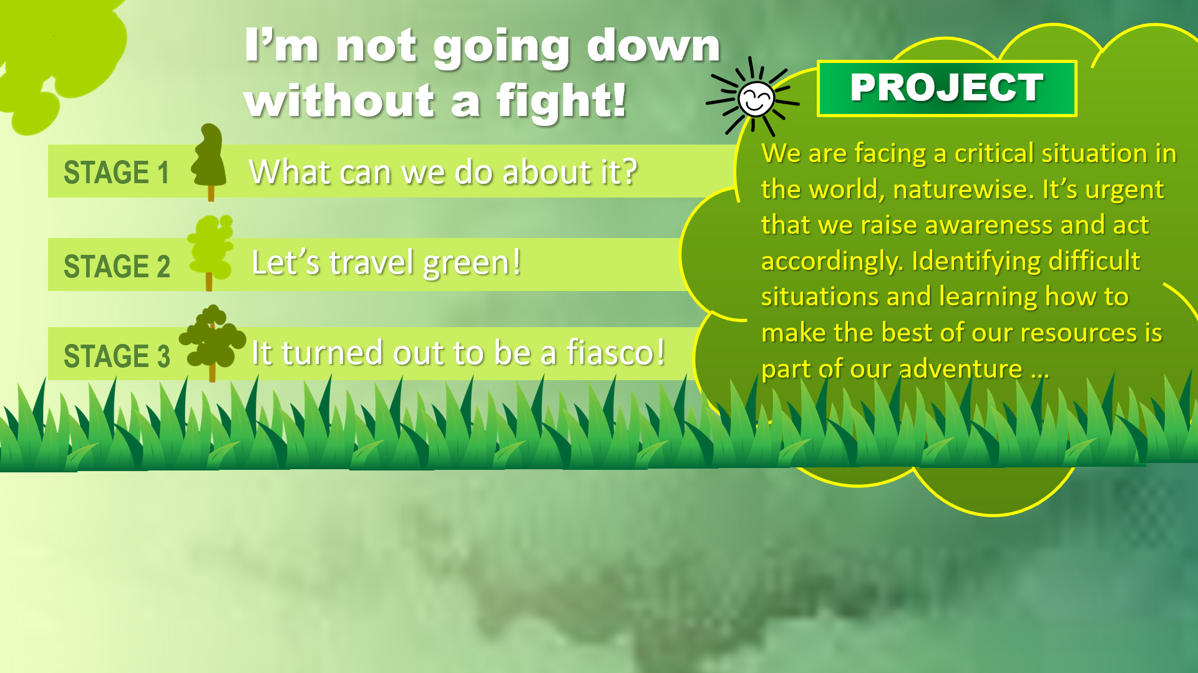

|  | | |
| --- | --- | --- |
| STAGE 2 | **I’m not going down without a fight!** | Team live class 5-minute presentation explaining the eco-trip, the itinerary and budget. |

| TEAM EVIDENCE MUST BE UPLOADED INTO CANVAS AND PADLET | | WRITTEN EVIDENCE | SPOKEN EVIDENCE |
| --- | --- | --- | --- |
| OBJECTIVE | B1 English students will become capable to understand what ecotourism is and develop hands-on proposals for an efficient eco-trip itinerary and budget through effective team collaborative work. | Slideshow + PDF | Live session Zoom video |
| Itinerary & Budget Excel file | - 5 minutes per team  - All team members participation  - No reading allowed |
| - Course and students’ information  - Content, images, and references  - Students’ reflections |

| STAGE 2 / Let’s travel green! | | | | | | |
| --- | --- | --- | --- | --- | --- | --- |
| **A. Gather with your collaborative team and discuss the destination for your eco-trip. Each member must mention a different destination so that the team can select one of the sites. Complete the chart below.** | | | | | | |
| DESTINATION DESCRIPTION | | TRIP DURATION | MEANS OF TRANSPORTATION | | | OTHER REQUIREMENTS |
| The Iztaccíhuatl (la mujer dormida) is an inactive stratovolcano (it is made up of 5 volcanoes), we can find it above the border of Puebla and México city.  Is the third biggest mountain in México.  Its height is 5,230 m and the last time it erupted was in 1868.  This mountain have the most interesting myth in the world about mountains, a ​​maid and a warrior fall in love. | | Recommendation to start the ascent at 2:24 am  6 to 7 hours to reach the top  Make stops to hydrate and eat (climbing Iztaccihuatl consumes around 7,000 to 9,000 calories)  The shelter is halfway (place to take refuge during snowfalls or storms; which has saved many lives), where you can go for a short period of time to warm up.  The most recommended time to go is between November and March (before the rains, because they cause cold weather and snowfall).  It is a return trip that takes approximately 12 and a half hours. | If what you want is to make a sustainable trip, you can travel by public transport, such as buses, you can use the rental of a Trosten truck, these include a personal driver, capacity for more than 10 people, such as some snack bars, Also the prices are very affordable.  On the other hand, you can use your own car but make sure to take more people to make a more sustainable trip. You can use apps like Google Maps that give you the best and safest routes. | | | If you want to scale the mountain and it is ones of your first times you need to go with an instructor, at the same time it is recommended to go with someone else for any trip problem.  Is important to go with the necessary clothes for the cold temperatures and some boots.  If you are going to camp, you need a sleeping bag and your own food. Scale clothes and scale kit. It is also important to wear sunscreen due to the high UVA and UVB radiation. And don’t forget the sunglasses.  You need to pay the fees for you stay in the national pack (access to Iztaccíhuatl); this area is designated so that tourists do not damage the local flora and fauna.  Essential chocolates, almonds (or other nuts) and water. |
| REFERENCES |  | | | | | |
| TEAM MEMBERS INFORMATION | NAME | | | TEC EMAIL | CELL PHONE | |
| Omar Reyes Barrueta | | | a01772756@tec.mx | 7121151968 | |
| Katherine Parra Valdez | | | a01742958@tec.mx | 6679961119 | |
| Lorenzo Emmanuel Carranza Becerra | | | a01712557@tec.mx | 9371674400 | |
| Gabriela Salazar Rodriguez | | | a01772753@tec.mx | 5649887567 | |
| Victor Daniel Perea Zelaya | | | a01029513@tec.mx | 5518087250 | |

| SLIDESHOW DRAFT | | **B. For each slide, write the specific information. (10 slides minimum)** | | | |
| --- | --- | --- | --- | --- | --- |
| SLIDE 1 | | SLIDE 2 | SLIDE 3 | SLIDE 4 | SLIDE 5 |
| Project title + course and professor’s information | | Collaborative team members names +  ID numbers | Destination description | Trip duration | Main needs for the trip´s itinerary |
| SLIDE 6 | | SLIDE 7 | SLIDE 8 | SLIDE 9 | SLIDE 10 |
| Means of transportation | | Other requirements (accommodation) | Costs | **Consulted references**  APA format  Images sources | **Reflections**  Every student must answer  How has this project helped me improve my language level and my previous understanding about sustainability? |
| SLIDESHOW LINK |  | | | UPLOAD THIS FILE, A PDF OF THE SLIDESHOW AND THE ITINERARY & BUDGET EXCEL FILE | |

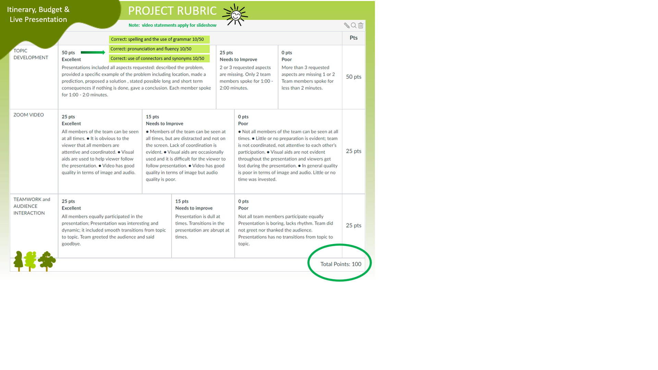Bibliography

Aprende de los expertos - Volcanes de México. (2020). Volcanes de México.

<https://volcanesdemexico.mx/blog/>

‌Equipo de redacción. (2022, December 19). Volcán Iztaccíhuatl. Geoenciclopedia.com; Geoenciclopedia.com. <https://www.geoenciclopedia.com/volcan-iztaccihuatl-243.html>

The Legend of Popocatepetl & Iztaccíhuatl: A Love Story. (n.d.). <https://as.vanderbilt.edu/clas-resources/media/The%20Legend%20of%20Popocatepetl.pdf>

May. (2023). The Legend of Popocatepetl & Iztaccíhuatl A Love Story. Inside Mexico. <https://www.inside-mexico.com/the-legend-of-popocatepetl-iztaccihuatl/>

‌Iztaccíhuatl - Volcanes de México. (2020, December 27). Volcanes de México. <https://volcanesdemexico.mx/volcanes/iztaccihuatl/>

‌Carey, L. (2017, October 12). Popocatepetl & Iztaccíhuatl: the Love Story of Mexico City’s Mountain Ranges. Culture Trip. <https://theculturetrip.com/north-america/mexico/articles/popocatepetl-iztaccihuatl-the-love-story-of-mexico-citys-mountain-ranges>

‌Iztaccihuatl Hike! Your guide to Climbing Iztaccihuatl. (2020, January 30). Holiday from Where. <https://holidayfromwhere.com/climbing-iztaccihuatl-hike/>

Bernal, J. (2020, November 11). Parque Nacional Iztaccíhuatl-Popocatépetl: ¿qué debes saber antes de visitarlo? - Mexico Travel Channel. Mexico Travel Channel. <https://mexicotravelchannel.com.mx/ecoturismo/20201110/parque-nacional-iztaccihuatl-popocatepetl/>

‌

‌

‌

‌